Lab 5 documentation

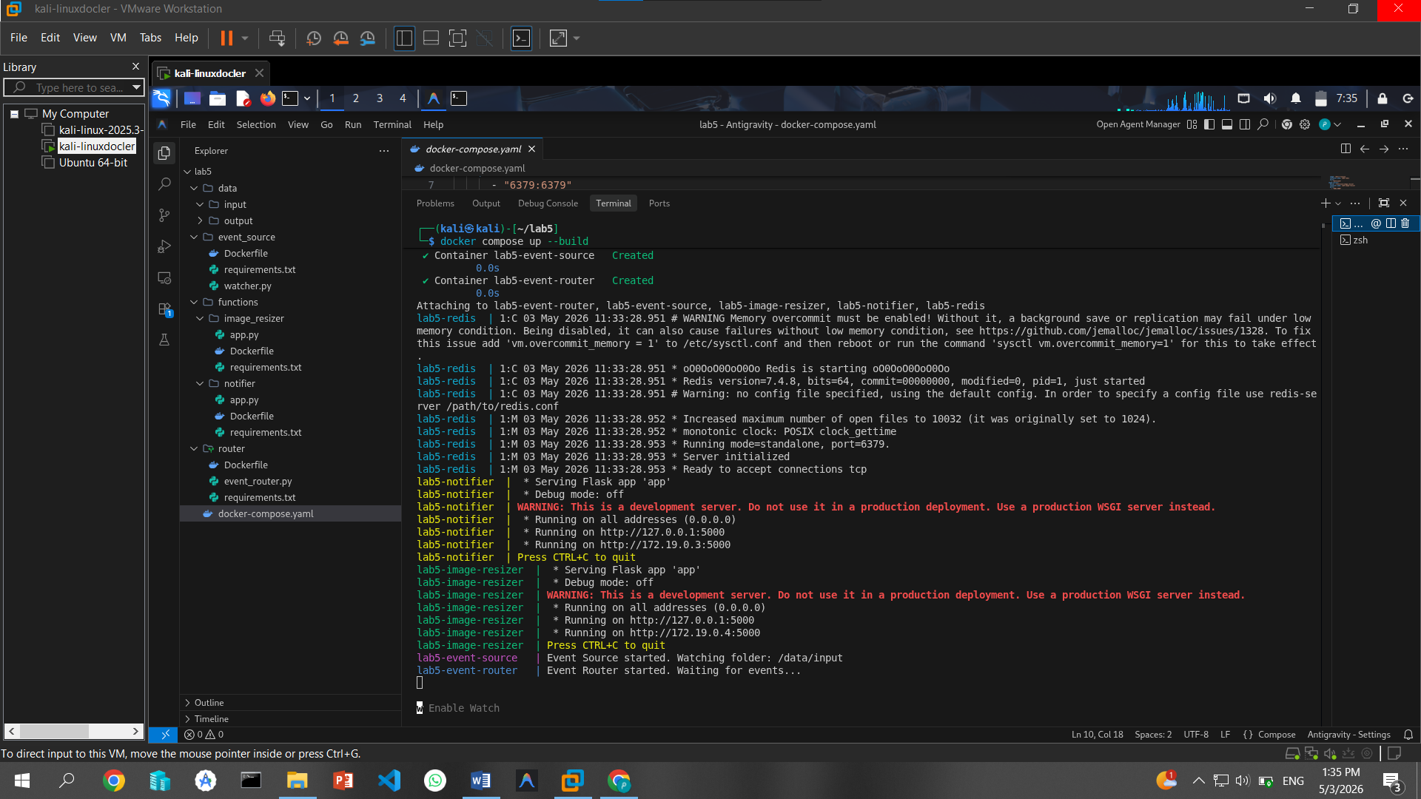
1 docker build files
1. data: This is a shared volume that acts as the physical storage for the pipeline.
input/: The "landing zone" where the Event Source watches for new images.
output/: The "destination" where the Image Resizer saves the processed (resized) files. 2.
2 event_source: This folder contains the Event Producer.
- watcher.py: A script that constantly monitors the input/ folder. When it detects a new image, it creates a message (event) and pushes it into the Redis Stream.
- Dockerfile: Defines the environment for the watcher to run as an independent background service.
3. router: This folder contains the Event Broker/Router, which acts as the "brain" of the architecture.
- event_router.py: It listens to the Redis Stream. When an event arrives, it checks a "routing table" and decides which functions need to receive that data via HTTP POST requests.
- requirements.txt: Includes libraries like requests so the router can talk to the other containers.
4. functions: This directory holds the individual Function-as-a-Service (FaaS) simulations. These are "loosely coupled," meaning they don't know about each other and only run when triggered by the router.
image_resizer:
- app.py: A Flask-based function that performs the heavy lifting. It opens an image from the input/ folder, resizes it using the Pillow library, and saves it to the output/ folder.
- Dockerfile: Sets up the Python environment specifically for image processing.
Notifier:
- app.py: A secondary function that demonstrates Event Fan-out. It receives the same event as the resizer but simply prints a log message to confirm the upload was successful.
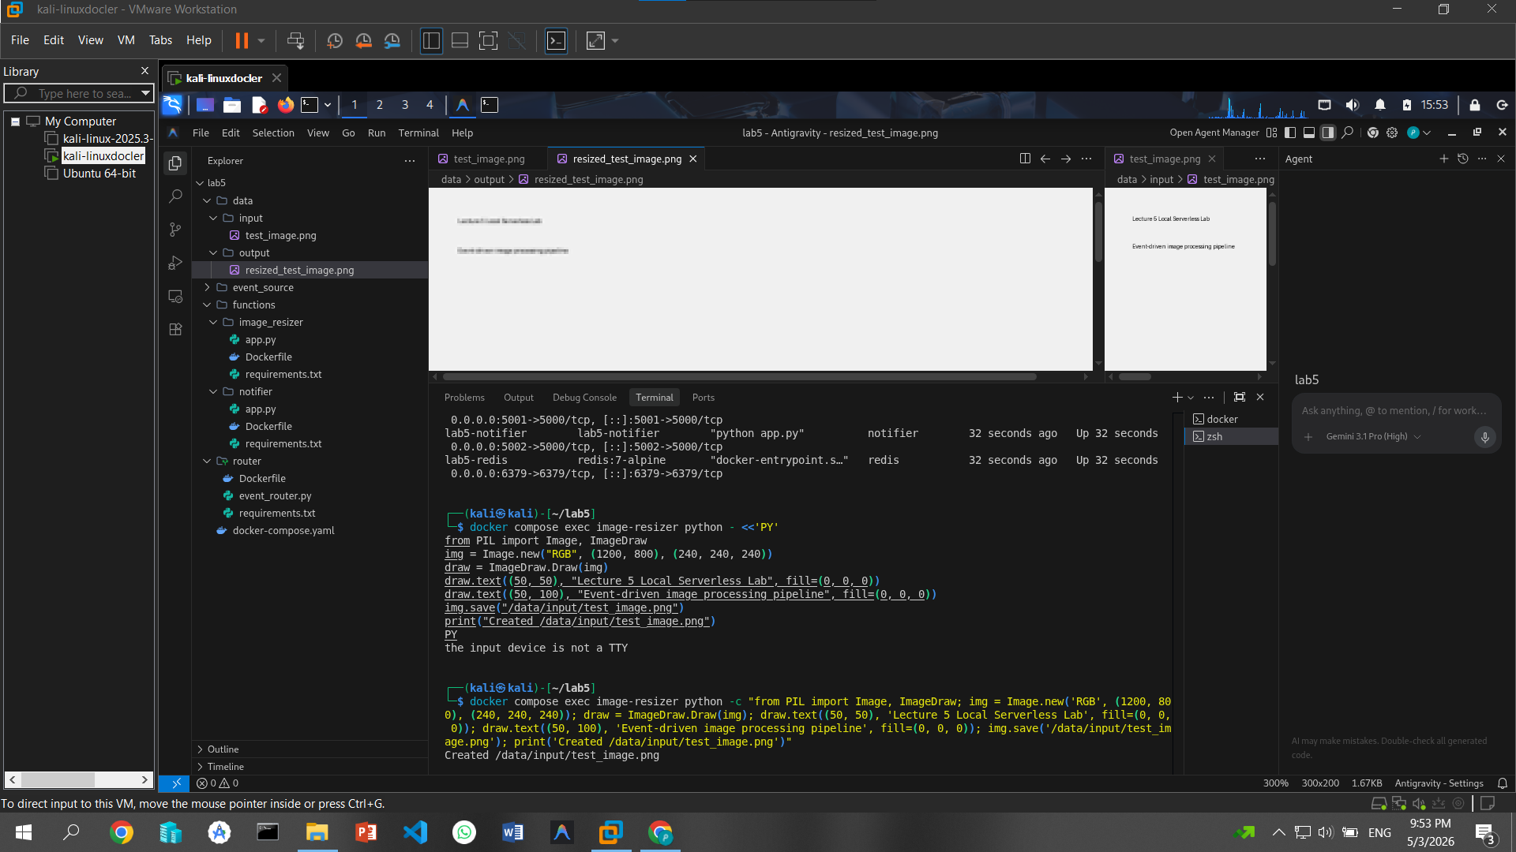
3 docker create images in input and output

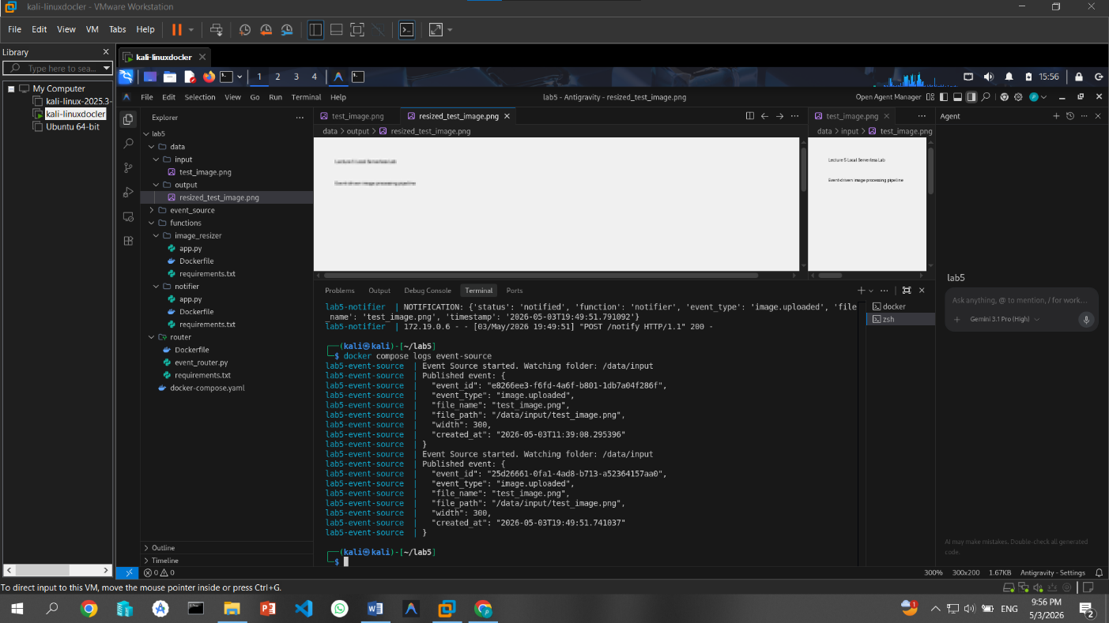
docker compose logs event-source

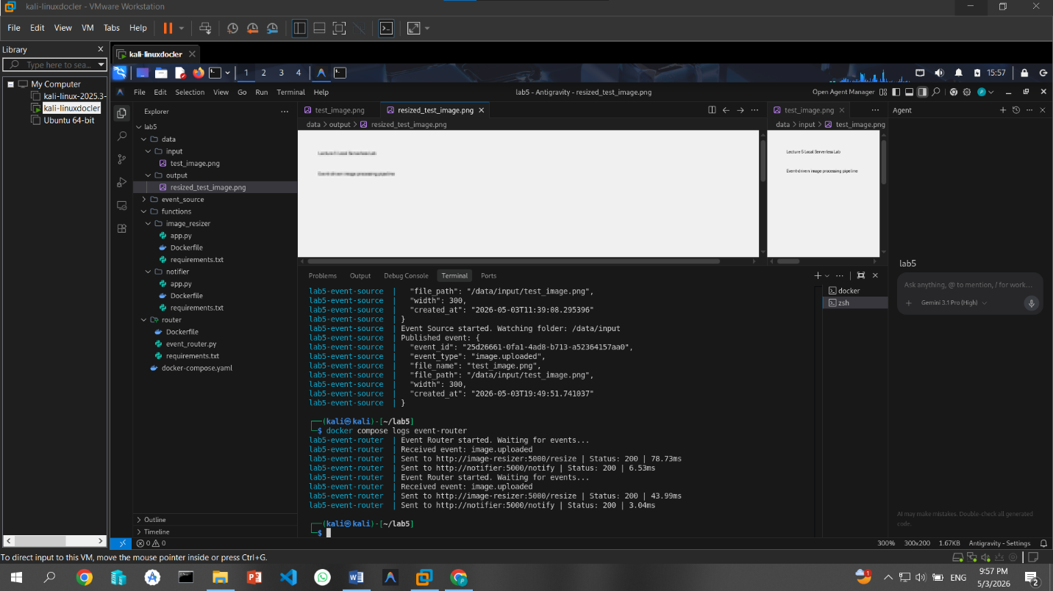
docker compose logs event-router
docker compose logs image-resizer
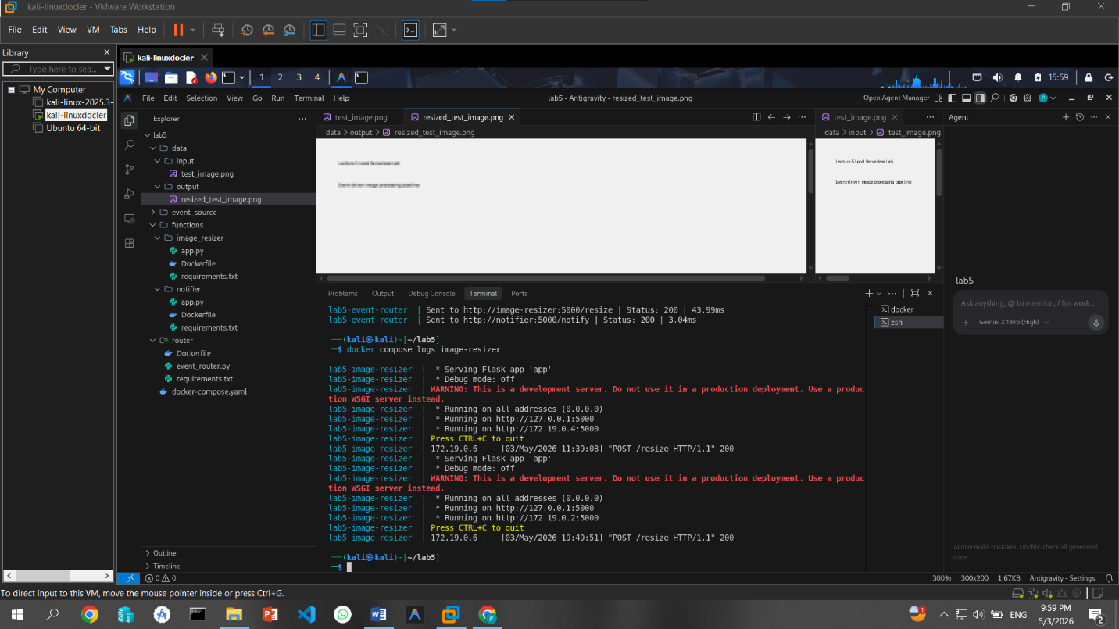
docker compose logs notifier
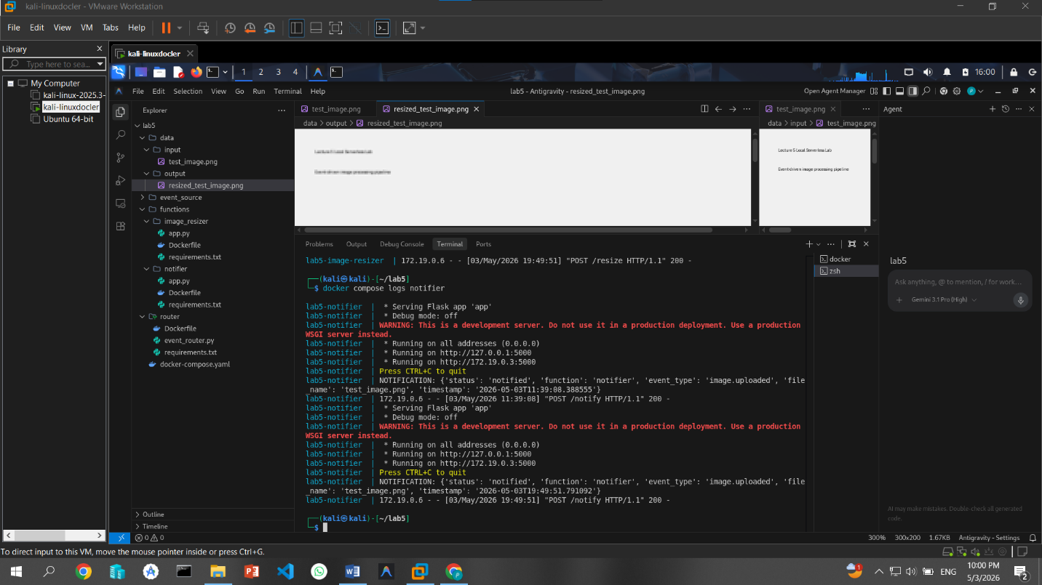

Cold start experiment:
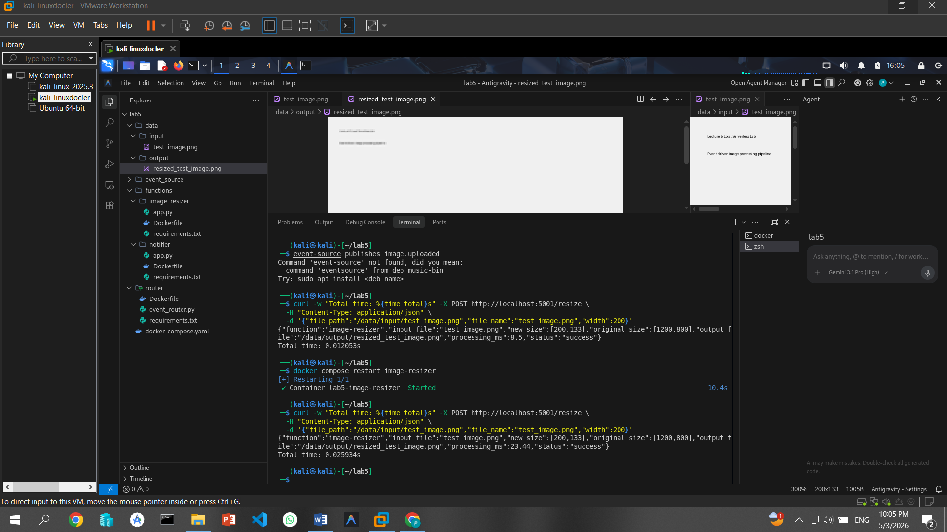
Warm Request (First Curl): Time: 0.012053s.
This represents a function that is already running and has its resources loaded in memory.

The Trigger: The command docker compose restart image-resizer simulates a serverless provider spinning down an idle function or a container being initialized for the first time.
Cold Request (Second Curl): Time: 0.025934s.

Finding:This request took over twice as long as the warm one. This is the "Cold Start" delay caused by the overhead of starting the Python runtime and the Flask application after the restart

